Learning Outcomes Assessment

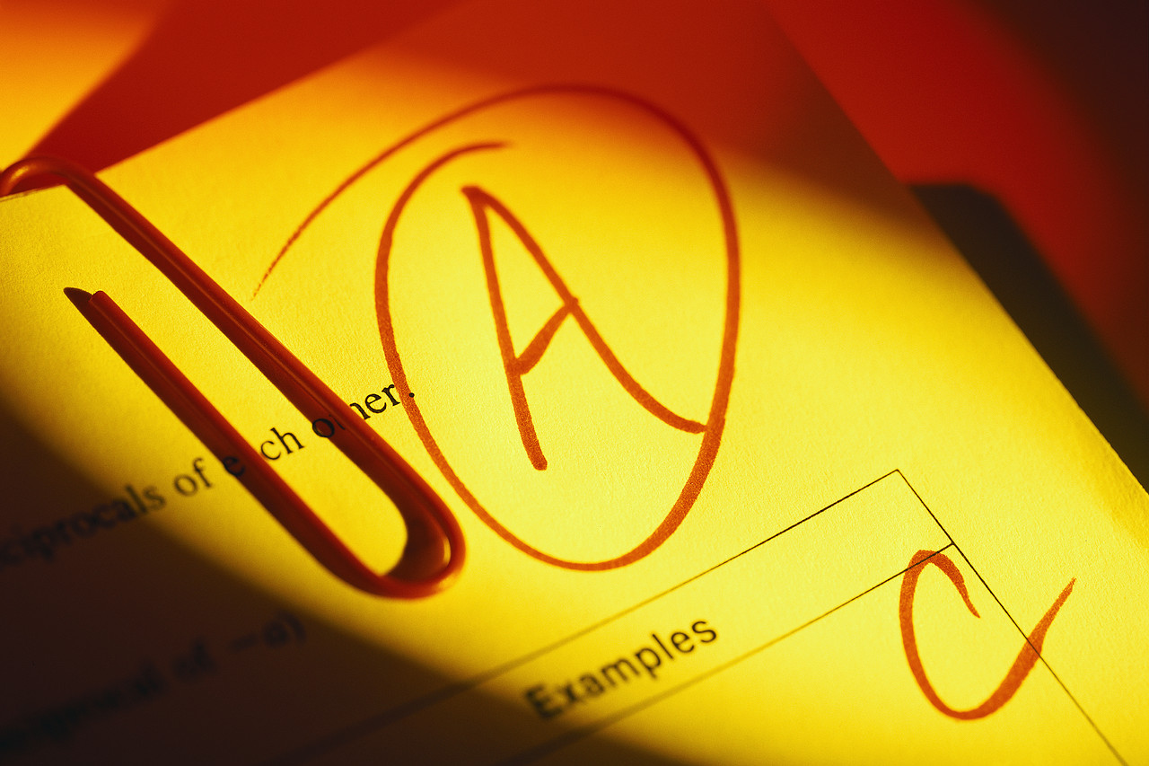

Colleges of the Arts and Sciences (ASC) Committee on Curriculum and Instruction (CCI)
Sub-Committee E

April 18, 2008
12:30p.m. - 2:30 p.m.
University Hall Museum

Members

David Andereck, Associate Dean, MPS
Alexis Collier, Psychology, CCI Sub-Committee E Chair, ASC
Steve Fink, English, HUM
Kate Hallihan, Director, Curriculum and Assessment, ASC
Keith Irvin, Animal Science, FAES
Jessica Mercerhill, Director, Special Interdisciplinary Programs, ASC
Mark Shanda, Theatre, ART
Mike Trudeau, Speech and Hearing, SBS
Mary Ellen Jenkins, Assistant Dean, Advising, ASC

AGENDA

I. Announcements (15 min)

II. Updates on ASC Exit Survey and NSSE Findings (15 min)

III. Writing Category Focus Group (15 min)

IV. Long Term Assessment Planning (45 min)
Assessment in General Education

Levels of Analyses Types of Evidence

Overall General Education Program  (General abilities; life-long learning)
  CLA (direct; value added)
  NSSE (indirect)
Categories of the GEC  (Category-specific learning goals)
  ASC Exit Survey (indirect)
  Across courses (direct & indirect)
Courses within GEC categories  (Category goals contextualized by course)
  Various direct and indirect methods
  e.g., embedded testing and surveys

